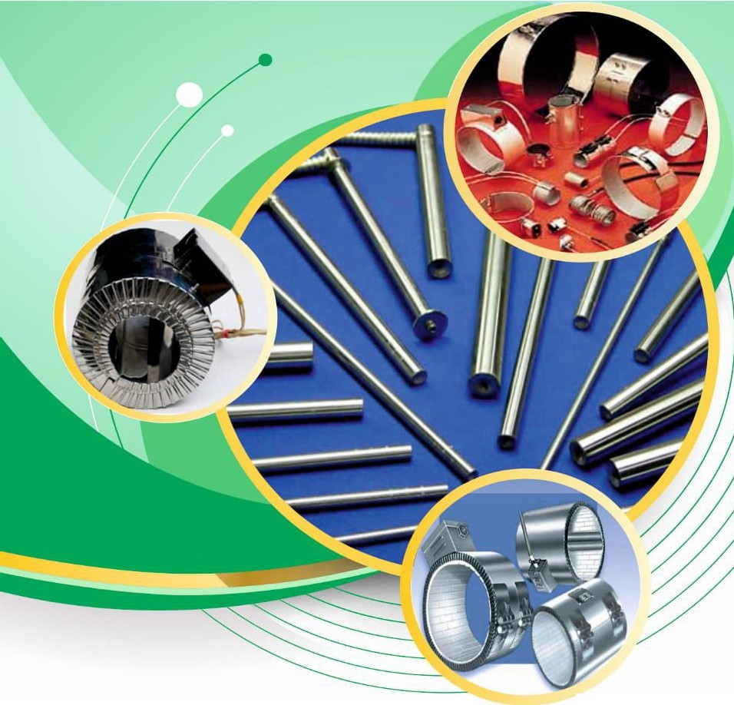


An ISO 9001 - 2015 Certified Company

MANUFACTURERS & EXPORTERS :
® | UKAS  . uo,11,"f  \ JtJ,t,
® | "'

ALL TYPES OF INDUSTRIAL HEATERS, THERMOCOUPLES,
RTD SENSORS ETC.
-.

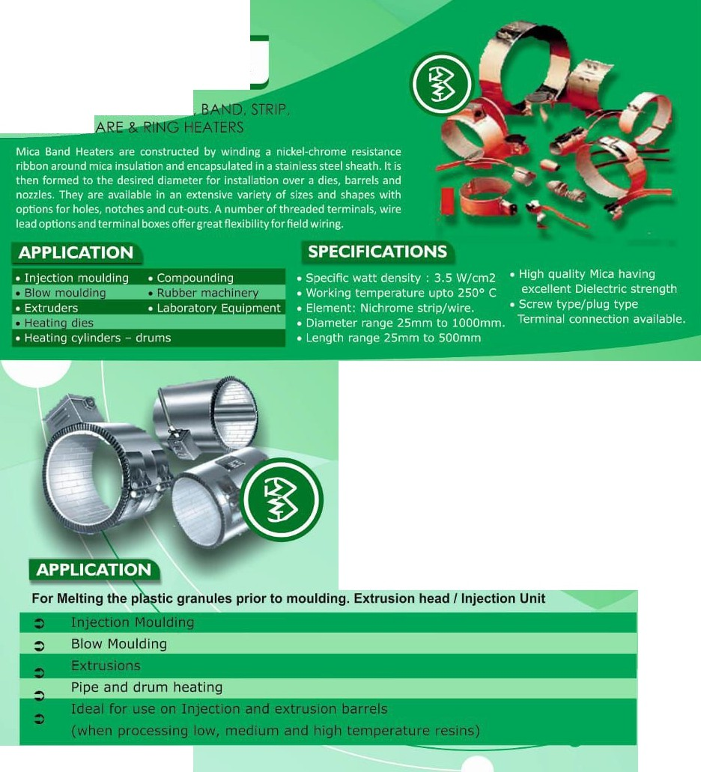
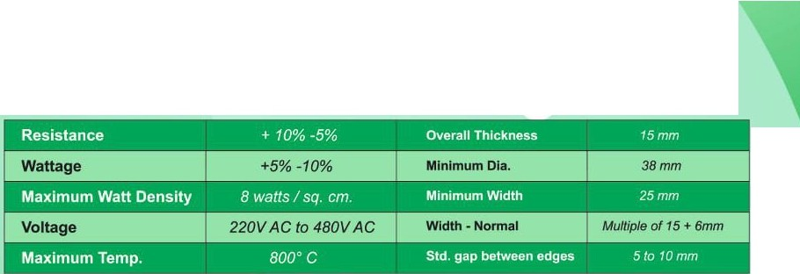
MICA BAND HEATERS

MICA INSULATED NOZZLE PLATE, SQU

CERAMIC BAND HEATER
)
I,
Ceramic Band Heaters were developed to meet industrial requirements for high temperature long lasting heaters. They are Ideally suited to comply with today's new resins, which calls for ever-increasing process temperatures.
Ceramic Band Heaters design consist of a helically wound resistance coll made from 80/20 nichrome wire, evenly stretched and precisely strung through a specially designed ceramic insulatmg bricks forming a flexible heating mat. The ceramic heating mat along with ceramic fiber lnsulatfon is placed on a stainless steel housing made with serrated edges providing maximum flexibility foreasy installation.

SPECIFICATIONS

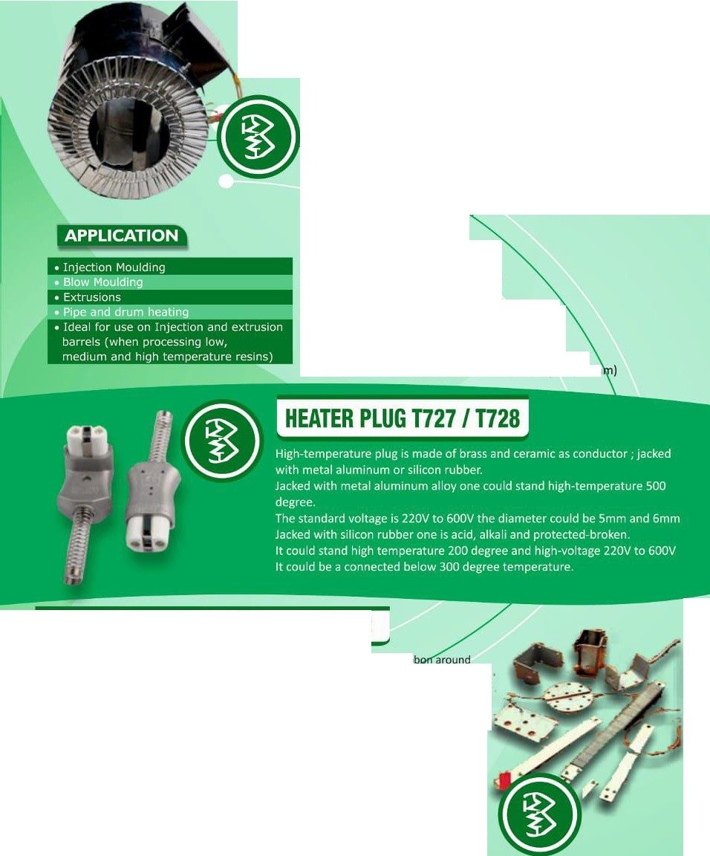
l MICA / CERAMIC ENERGY SAVING HEATERS j

Unique Insulation Plus Band Heaters are Specifically designed and engineered to meet the ever increasing demand for energy conservation and to improve operation efficiency capable of generating higher temperature essential to process today's high temperature resins.
Energy Conservation is achieved by using 1" thick Ceramic fiber insulating blanket on the outer surface increasing the overall outer ait.n!Ae.t:ger by 2"(Mlnimum Length Required is 4"). Reducing power consumptl to 30% because of low thermal conductivity of the
ceramic fiber In tion, the external surface temperature of the insulation plus cera • band heater is approximately so•c while
runningthe inside surface t erature at 300°C.

FEATURES
:> Saving Energy Up to 30%
:> Reduce Wattage of Heater
:> More Uniform Heating
:> Less Down time increases Productivity
:> Reduced Preheating time of Machine
:> Heater cost is recover in shorter time
:> Cool working atmosphere for operator
:> Overall Outer diameter increases by 2" (SO m

l MICA/ CERAMIC STRIP HEATER
Mica Strip Heaters are constructed by winding a nickel-chrome resistance rib
mica insulation and encapsulated in a stainless steel sheath. They are av • e in an extensive variety of sizes and shapes with options for holes, notch cut-outs. A number of threaded ter. • als, wire lead options and terminal box r great flexibility for field wiring. These ti r lastic • p cations andfor anywhere heat Is needed on aflat or curved surface.

CERAMIC STRIP HEATER (WITH & WITHOUT FINS)
Ceramic Strip Heaters are constructed with ceramicinsulation that quickly conducts heat from the resistance wire to the sheath resulting in low internal temperatures and long heater life In the most demanding applications. Precise placement of the resistance wire provides uniform sheath temperature across the width and along the entire heated length. This is an extremely rugged construction capable of high temperatures andhigh watt densities.
Fins increase the heat transfer surface area to allow higher wattages than standard Strip Heaters. These are intended to be operated with a substantial airflew and are typically used in heating tunnels, dryers or any application that requires a hot air source.

LOW & MEDIUM WATT DENSITY CARTRIDGE HEATERS
The heater design consists of helically wound resistance coil
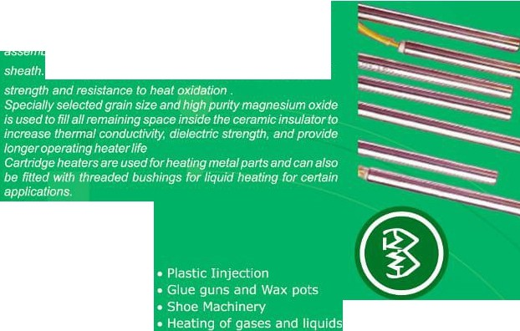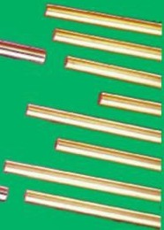
made from nickel-chrome wire, evenly stretched and strung
through holes in a round ceramic insulator.
.
. ...
. .
This alloy p_rovides the best combination of p_hy_sical
APPLICATION

HIGH WATT DENSITY CARTRIDGE HEATER

Cartridge heaters can be considered "component heaters" that are u o heat up many different applications. Primarily used in mould, these heaters t snug inside a cavity and helps heat solids by reaching high temperatures. Cartri e heaters have the versatility of being able to carry thermocouple inside to help control temperatures of theheater moreaccurately. Variousdiametersa wfor itto be used in any cavity and can be custom designed with any cold secti . Lead wires extend fromtheend to yourcontrols.
The construction of high temperature cartridge heaters P. sitions a nickel-chrome resistance wire precision wound around a magnesium ox· ecore. It Is inserted into a stainless or lncoloy tube locating the resistance wire c se to the sheath. The core is centrally positioned within the tubeand filled with gnesium oxide powder. Nickel pins pass through the centre of the core making ntact with the resistance wire at both ends. The whole is assembly is highly c pacted by a swaging operation and thus ensuring excellent heat transferto th xternal sheath. One end of the heater is closed with a welded metal end-disca wire leads exit at the opposite end which is typicallyclosed witha lavaseal.Av ·etyofwireleads andleadprotection optionsare available. Heaters can be su ed with Internal thermocouples, mounting fittings

andmanyotheroptions

:> Hot Runner Bushings
:> Marking & Sealing Machinery
:> Packaging Industry
:> Medical & Laboratory Apparatus
:> Shoe Making Industry
:> Die and platents
FEATURES
:> Unique winding design allows faster heating and longer life
:> Fine grain high purity magnesium oxide (MgO) fills any voids around
the resistor wire to optimize heat transfer, dielectric strength
and life of the heater.
:> Operated at Higher temperatures

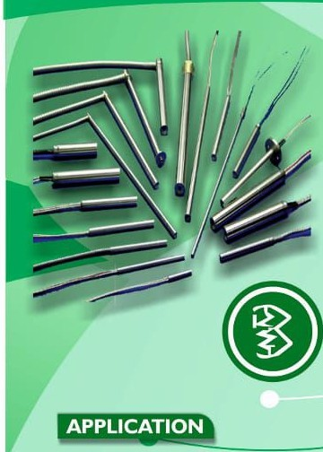



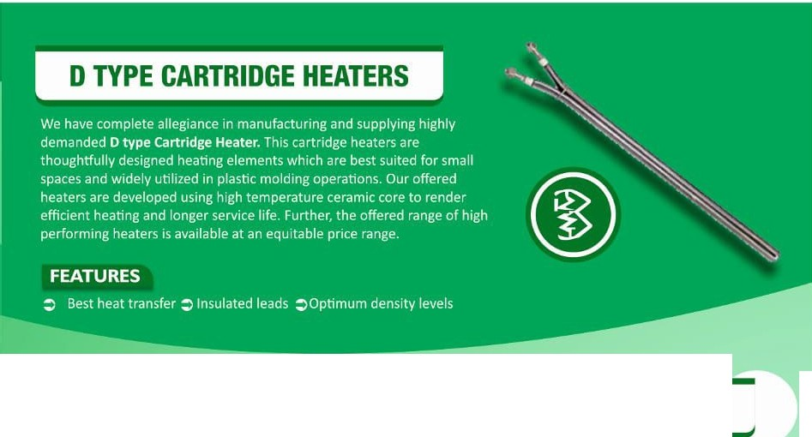
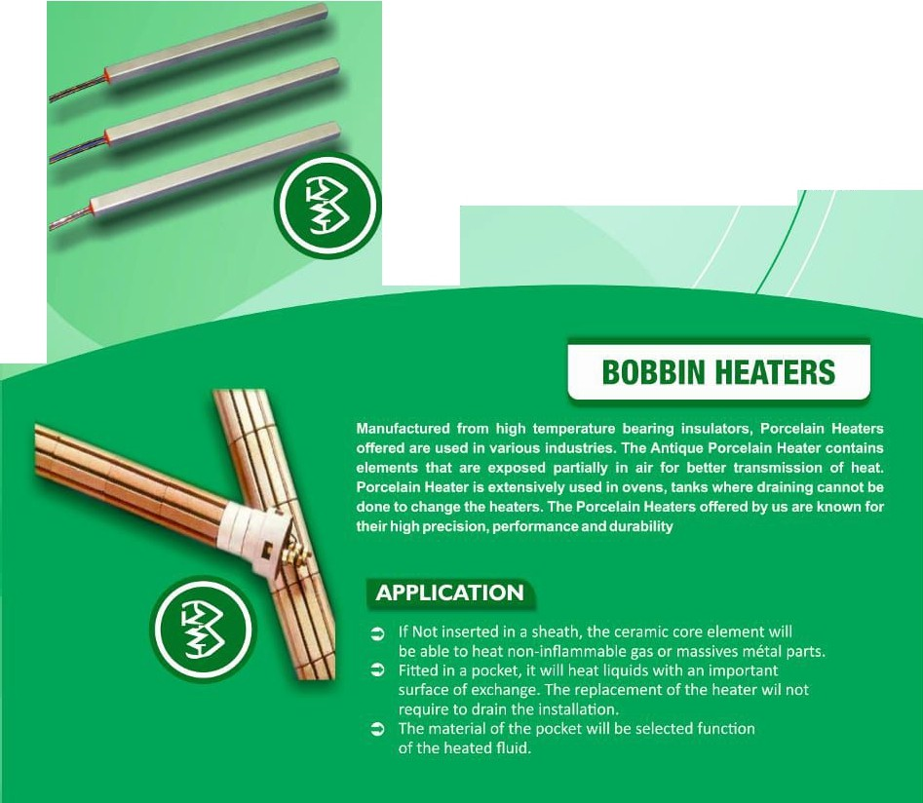

l SQUARE CARTRIDGE HEATER
Square cartridge heaters combine the utility of a square configuration with the high watt density capabilities of swaged construction. The square cartridge offers the reliability and performance required forthemost demanding of applicatio
Our total commitment to engineering excellence is reflecte m our successful efforts to improve heater performance and pr auction efficiency.

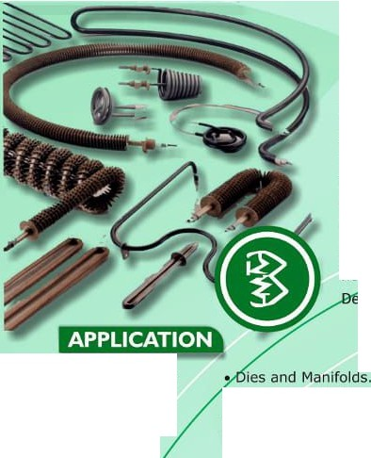
TUBULAR AIR HEATER J
Tubular Elements are the most versatile, dependable and rugged of any heat generation device. These qualities make it an ideal heat source for many applications. Precision wound 80-20 nickel-chrome wire to deliver an even heat distribution to the element sheath. High purity, grade A magnesium oxide is used asthe internal insulation to insure the best thermaltransfer andinsulation resistance. A variety of electrical terminations, mounting fittings and brackets, alongwiththe • integration intoany
heati stern. this heater are also rnanufatured for high ternpreture upto 600 greeC

- Radiant Heating
- Ovens
- Dryers
- Sealing Bars
- Dehumidifier.

- Immersion Heating.
- Contact heating .
- Chemical industries.
FEATURES
:> Custom-formed to meet specific requirements
:> Precision wound resistance wire for long heater life
:> Superior heat transfer.
:> Variety of lengths available
:> Easy to install

- Conve • Gas.
- • 'nk packaging.
:> High mechanical and chemical resistance

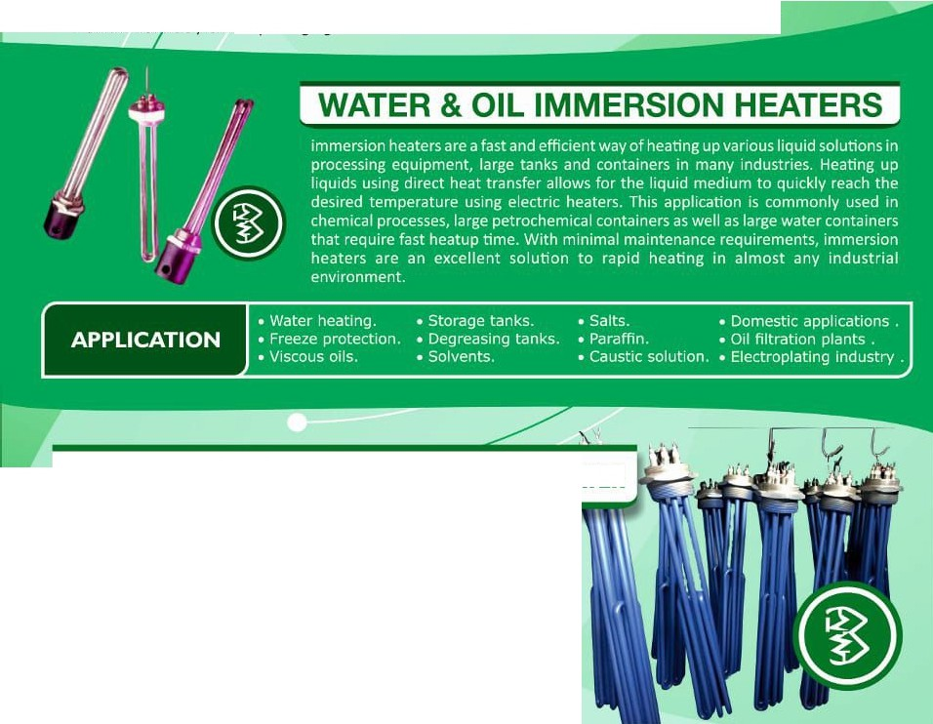

ANTI SCALE & ANTIRUST WATER IMMERSION HEATER

These Heaters Are Designed Specially For Preventing White Stalling And Rusting Of Heater Tube Due To Hard Water.
Coating Protect Heaters From Stalling & Rusting Which
Extends Life And Prevents Failure Of Heaters Due To Bursting And Corrosion.

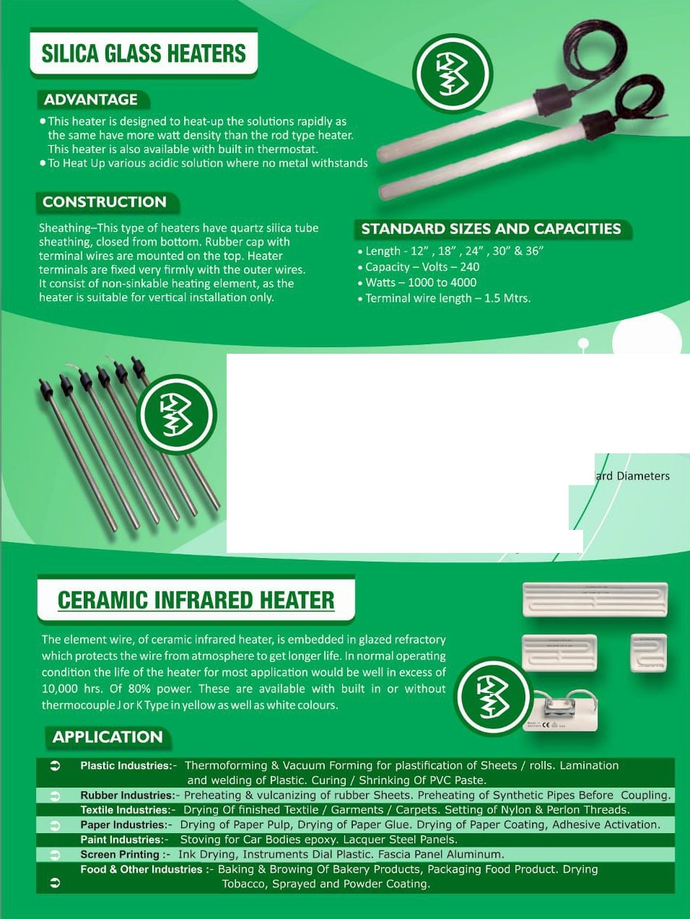


ELECTROPLATING / TITANIUM IMMERSION HEATER

Titanium Heaters Are Sheathed In Best Quality Titanium Tube Using Hi Conductivity MGOPowder For Efficient HeatTransfer AndLonglife.
Titanium Heater Is Mainly Used In Electroplating And Chemical industry Fo Prevention
Of High Corrosion Due To Chemical Reaction.
Available In Various Lengths As Per Customer Requirement And Stand
25mm,38mm &45mm
Ii ti i•hti..
  - Compact design • Easy operat' n
  - Low maintenance • High dura ity

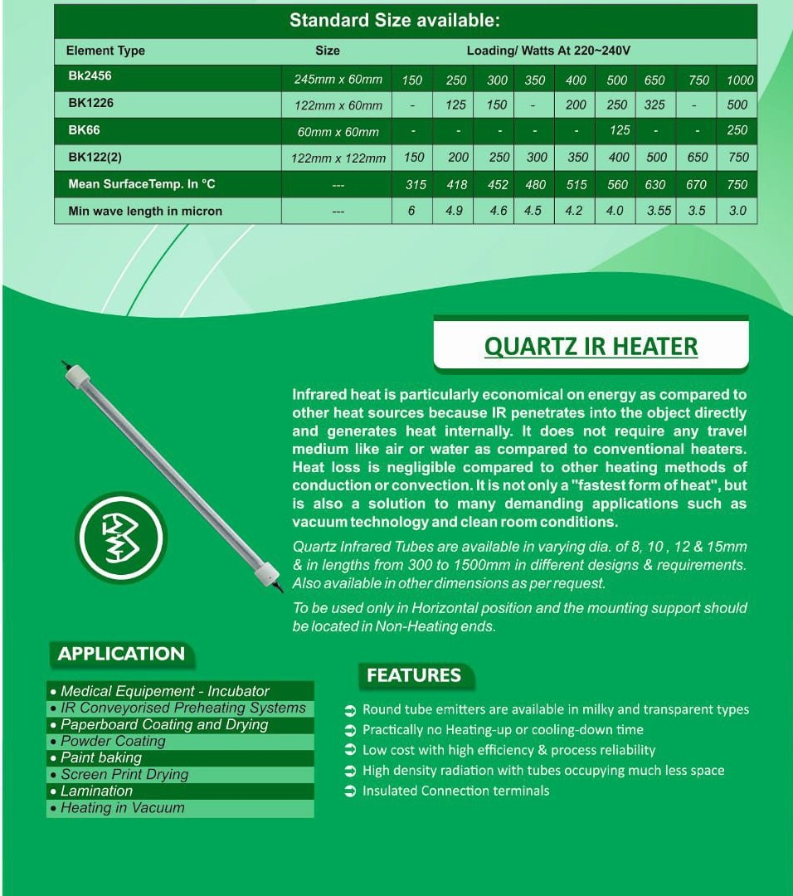
FEATURES
- Heat up time reduced by over 40%.

- Energy saving of over 15% in some applications.
- Lightweight construction with low thermal mass.

Short Wave IR Lamp transmits heat in the form of electromagnetic waves at a velocity of approximately 3,00,000 Km/Sec i.e., at the speedoflight.
These lamps are not only the fastest in transmitting heat but are most suitable for specific applications involving vacuum technology anddust free(clean room) conditions.
ADVANTAGE

SHORT WAVE IR HEATER

(Qr--(. -))jj

:>Heating is done by radiation, this eliminates loss of energy ·1·;•1'"'A"A !"(ll"!-t"l"'lal!!'!i"(•'!',].".:.. .. used for heating media and heat loss due to convection

:> Here the infr es penetrate the mater , hich it falls and delivers the heat directly to that material
DAA!t:MU•):1
:>Short wave IRlamps are available in different lengths from S" to 30" or as per customer specifications.
:> PET preform heating in stretch blow molding machines
:> Printing ink drying in offset machines
:> er coating drying
:> Pre - n rior to embossing
:> S in on T - shirts
:> 1

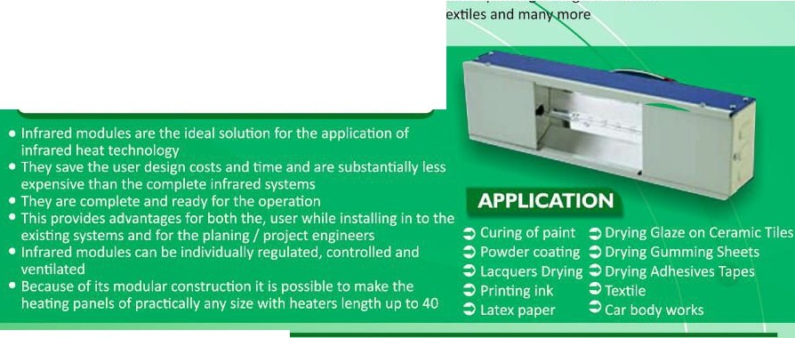
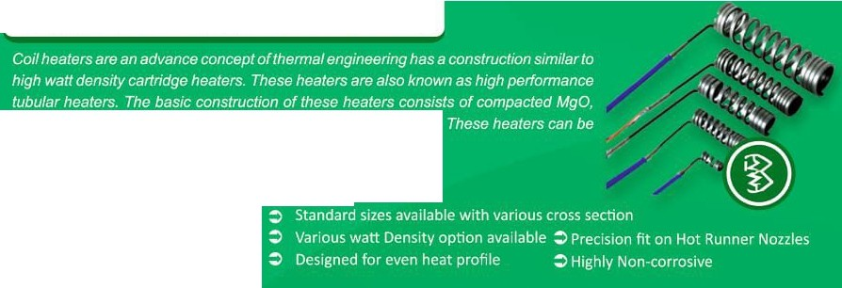

SHORT WAVE INFRARED MODULE
HOT RUNNER / MOULD COIL HEATERS
high temperature resistance wire and chrome Nickel Steel tube.
•
..
•
APPLICATION
FEATURES

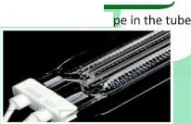
( TWIN TUBE SHORT WAVE INFRARED MODULE
This ls made up of 8-shape high-purity clear quam twin tube, each tube has Heating Coil of Tungsten material which runs In Usha which is filled with halogen gas.
- Power Density up to lSOKW/m' is-achieved. Heating up and cooling down time isapproximately one second
- These heaters are avallable with gold reflector and without reflector
- Reflector is In the form of gold coating on outer rear side of the tube
- Due to reflector heat loss from backside ls prevented and thuspower saving is achieved
- This also results In making surrounding work area cooler
- This also increases the efficiency and directionality of the heater
- There are two standard sizes 11 mm x 23 mm and 15 mm x 32 mm in cross section. Maximum length available is 2000 mm

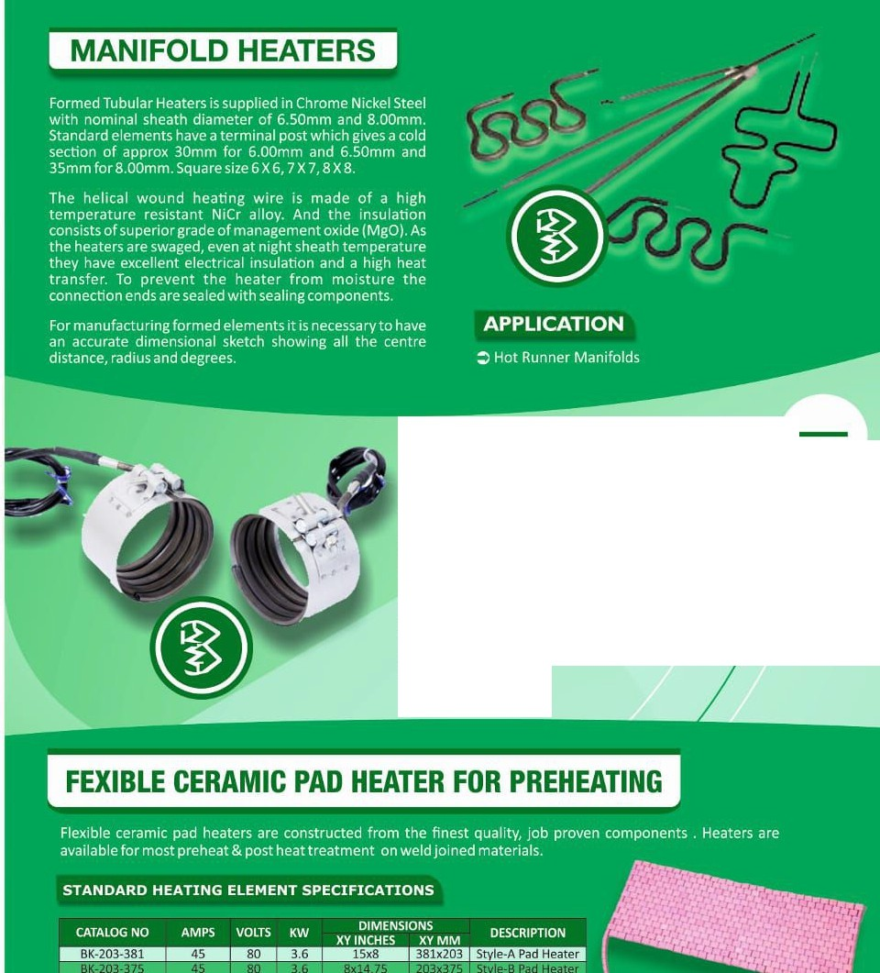
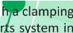
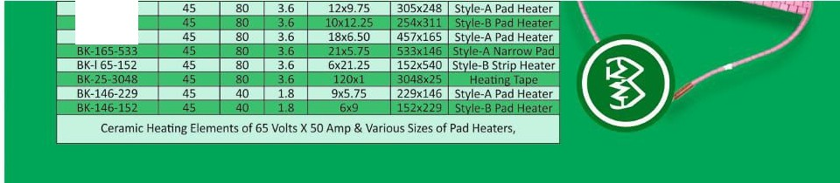

l COIL NOZZLE HEATER
We are offering an exclusive range of Nozzle Heaters to our clients. These offered products are manufactured by making use of supreme quality raw material procured from the established ve s of the industry. Besides, the offered products are provided wit
band, which is made up of chrome nickel steel, suppo
transferring maximum heat. We have developed thes products in accordance with the defined quality parameters of th industry so as to ensure their unsurpassed standards. Our valued ients can avail these offered tubes in different grades and specific ·ons as per their requirements.

BK-248-305 BK-248-254 BK-165-457

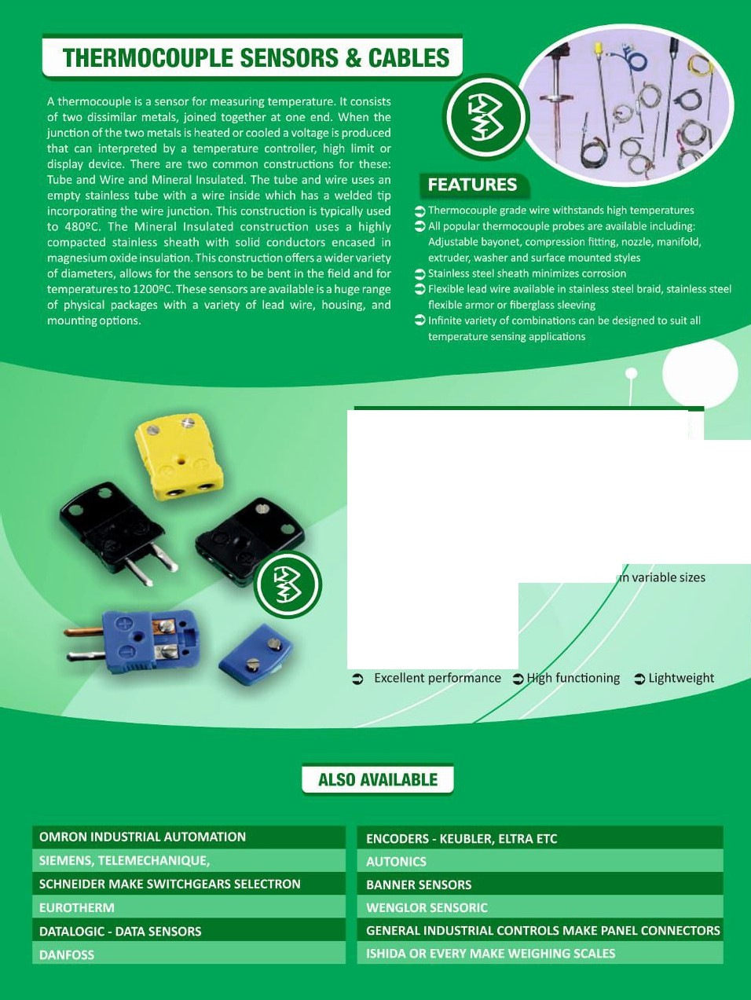

l THERMOCOUPLE CONNECTORS J
Owing to our vast experience, we have been succ ul in catering to the requirements of our esteemed 1ents by offering quality Thermocouple Connector. These nnectors are manufactured usingoptimum quality plastica d steel that are sourced from trustworthy vendors of th market. Our range is used to connect wires and isavailable·
as perclient's specifications.

FEATURES

